

Topic:

Building a Sitemap for a Software System

Objective of the work:

The purpose of this task is to strengthen the skills of designing software architectures through the creation of a site/application structure (sitemap) based on use cases. The sitemap serves as a visual representation of the system, showing the hierarchy and relationships between its pages.

Task
- Take the software system for which you created a Use Case diagram in Laboratory Work №1.
- Build a Sitemap (structural map of the site/application), which should include:
• The Main Page / Main Menu.
• The main sections of the system corresponding to the key use cases.
• Subsections/pages for performing specific actions.
• Relationships (hierarchy or transitions) between the pages.
3. Specify the correspondence between the pages and the key use case scenarios.
4. Create a diagram using a diagramming tool (e.g., Lucidchart, draw.io, StarUML, Visual Paradigm, or any other tool).
Example for Library Management System (as in your Lab 1):
Main Page
- Book Search
  - Search Results
  - Book Page (description, author, genre, status)
  - Book Reservation
- User Account
  - My Reservations
- Librarian’s Dashboard
  - Add Book
  - Delete Book
  - Confirm Reservation
- Administrator Panel
  - User Management
  - System Statistics
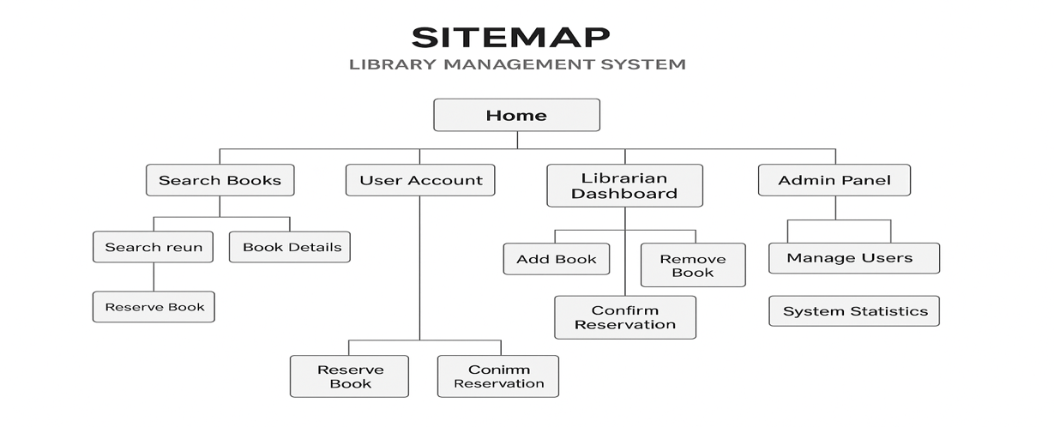

Report Requirements:
- Title page.
- Purpose of the work.
- Sitemap diagram (in the form of a block diagram).
- A table or a brief description showing which pages correspond to which use cases.
- Conclusion.
Other examples:

